1. We are sending the JWT token as the part of authentication. But if we must pass the user roles to it as well, we need to have something called JWT callback.
2. So, we implemented the callback

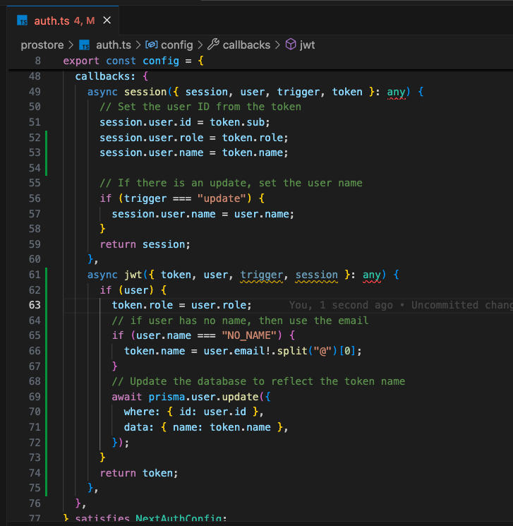

* Whenever there is a successful sign-in, the provider sends the user object back. So, the user object has the role in the database. So, we are just assigning that role from user to our token using this callback function.

